**Project Types**

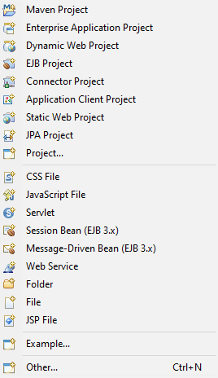

* Maven Project – a project which uses Maven to help download dependencies, referring to libraries or JAR files
* Enterprise Application Project – EAR – an enterprise application project contains a set of references to other J2EE modules and Java projects that are combined to compose an EAR file. These projects can be Web modules, EJB modules, application client modules, connector modules, general utility Java JAR files, and EJB client JAR files
  + [Enterprise application projects - IBM Documentation](https://www.ibm.com/docs/en/radfws/9.6?topic=SSRTLW_9.6.0/org.eclipse.jst.j2ee.doc.user/topics/cjearproj.htm)
  + Ties together resources that are required to deploy a J2EE Enterprise Application
  + Enterprise application projects are exported as EAR files that include all files defined in the Enterprise Application project as well as the appropriate archive file for each J2EE module or utility JAR project defined in the deployment descriptor, sub as Web archive (WAR) files and EJB Jar Files
  + Can contain utility JAR files that are to be used by the contained modules. This allows sharing of code at the application level by multiple Web, EJB, or application client modules
  + Utility JAR files can be actual JAR files in the project, or you can include utility Java projects that are designated to become the utility JAR files during assembly and deployment
* Dynamic Web Project – dynamic Java EE resources such as servlets, JSP files, filters, and associated metadata, in addition to static resources such as images and HTML files. Static web projects only contains static resources. WAR file.
* EJB Project – used to organize the resources contained in an EJB module, used to assemble one or more enterprise beans into a single deployable unit. It is deployed in a standard archive (JAR) file
* Connector project – contains resources required for J2EE resource adapter. A resource adapter is a system-level software driver that enables J2EE components to communicate with a back-end enterprise information system
* Application Client Projects – contain the resources needed for application client modules and programs that run on networked client systems. An application client project is deployed as a JAR file. Guides the user through creating a J2EE connector project, which includes specifying the associated enterprise application project and a set of facets applicable to it
* Static Web Project – written entirely using HTML, each web page is a separate document and there are no databases or external files that are drawn upon
* JPA Project – Java Persistence API is one possible approach to ORM. Via JPA the developer can map, store, update, and retrieve data from relational databases to Java objects and vice versa. JPA can be used in Java-EE and Java-SE applications.

Java Unit Testing

Containerize Apps

Resource Adapter

Contextual Sense